**Detailed Report on Network Cable Preparation, IP Configuration, and Network Tools**

**Bachelor of Technology**

**Computer Science and Engineering**

Submitted By

NAME – ABHIRUP BAG

ROLL NUMBER – 13000122082

DEPARTMENT – CSE(B1)

SEMESTER – 6

PAPER – Computer Networks Lab

(PCC-CS692)

February 2025



**Techno Main**

**EM-4/1, Sector-V, Salt Lake**

**Kolkata- 700091**

**West Bengal**

**India**

**Table of Contents**

1. **Introduction**
2. **CAT-5/CAT-6 Cable Preparation with RJ-45 Connector**  
   2.1 Tools Required  
   2.2 Wiring Standards (TIA/EIA-568A & TIA/EIA-568B)  
   2.3 Straight-Through vs. Crossover Cabling  
   2.4 Steps to Crimp an RJ-45 Connector
3. **IP Address Configuration on Windows and Linux**  
   3.1 Static IP Configuration  
   3.2 DHCP Configuration
4. **Network Tools and Commands**  
   4.1 ipconfig (Windows)  
   4.2 ifconfig (Linux)  
   4.3 ip  
   4.4 hostname  
   4.5 ping  
   4.6 netstat  
   4.7 route  
   4.8 traceroute / tracert  
   4.9 tcpdump  
   4.10 Wireshark
5. **Conclusion**
6. **References**

**Detailed Report on Networking Concepts and Tools**

1. **CAT-5/CAT-6 Cable Preparation with RJ-45 Connector**
   1. **Introduction**

CAT-5 and CAT-6 cables are twisted pair cables used in networking for connecting devices like computers, routers, and switches. These cables use RJ-45 connectors for termination.

* 1. **Tools Required**
     1. CAT-5/CAT-6 cable
     2. RJ-45 connectors
     3. Crimping tool
     4. Cable stripper
     5. Network tester
  2. **Wiring Standards**

There are two standards for Ethernet cabling:

* + - 1. TIA/EIA-568A (T568A)
      2. TIA/EIA-568B (T568B)
  1. **Used for connecting different devices (PC to switch, switch to router). The wire order remains the same on both ends.**
     1. **Straight-through cable:** Used to connect different types of devices (e.g., PC to switch, switch to router).
     2. **Crossover cable:** Used to connect similar devices (e.g., PC to PC, switch to switch).

**Straight-Through Wiring (T568B Standard)**

|  |  |
| --- | --- |
| **Pin** | **Colour** |
| 1 | Orange-White |
| 2 | Orange |
| 3 | Green-White |
| 4 | Blue |
| 5 | Blue-White |
| 6 | Green |
| 7 | Brown-White |
| 8 | Brown |

**Crossover Wiring (T568A on One End, T568B on Other)**

|  |  |
| --- | --- |
| **Pin (End 1 - T568A)** | **Pin (End 2 - T568B)** |
| 1 (Green-White) | 1 (Orange-White) |
| 2 (Green) | 2 (Orange) |
| 3 (Orange-White) | 3 (Green-White) |
| 4 (Blue) | 4 (Blue) |
| 5 (Blue-White) | 5 (Blue-White) |
| 6 (Orange) | 6 (Green) |
| 7 (Brown-White) | 7 (Brown-White) |
| 8 (Brown) | 8 (Brown) |

* 1. **Steps to Crimp an RJ-45 Connector**
     1. Strip about 1 inch of the cable’s outer sheath.
     2. Untwist and arrange the wires according to the desired standard.
     3. Insert the wires into the RJ-45 connector.
     4. Use the crimping tool to secure the connector.
     5. Test the cable using a network tester.

1. **IP Address Configuration (Static and DHCP) on Linux and Windows**
   1. **Windows Configuration**
      1. **Static IP Configuration**
         1. Open Control Panel → Network and Sharing Centre → Change adapter settings.
         2. Right-click on the network adapter → Properties.
         3. Select "Internet Protocol Version 4 (TCP/IPv4)" → Properties.
         4. Select "Use the following IP address" and enter details.
         5. Click "OK" to apply changes.
      2. **DHCP Configuration**
         1. Follow steps 1-3 above.
         2. Select "Obtain an IP address automatically".
         3. Click "OK" to apply changes.
      3. **Linux IP Configuration**
         1. **Static IP Configuration (Ubuntu/Debian)**
            * Open Terminal.
            * Edit network configuration:

sudo nano /etc/netplan/00-installer-config.yaml

* + - * + Add the following:

network:

  ethernets:

    eth0:

      dhcp4: no

      addresses: [192.168.1.100/24]

      gateway4: 192.168.1.1

      nameservers:

        addresses: [8.8.8.8, 8.8.4.4]

  version: 2

* + - * + Save and exit. Restart the network service:

sudo netplan apply

* + - 1. **DHCP Configuration**
         * Modify /etc/netplan/00-installer-config.yaml

network:

  ethernets:

    eth0:

      dhcp4: true

  version: 2

* + - * + Apply changes:

sudo netplan apply

1. **Important Network Tools and Commands**
   1. **ipconfig (Windows)**

Displays network configuration details.

ipconfig /all

**Example output:**

IPv4 Address: 192.168.1.100

Subnet Mask: 255.255.255.0

Default Gateway: 192.168.1.1

* 1. **ifconfig (Linux)**

Displays network interface information.

iconfig

**Example output:** 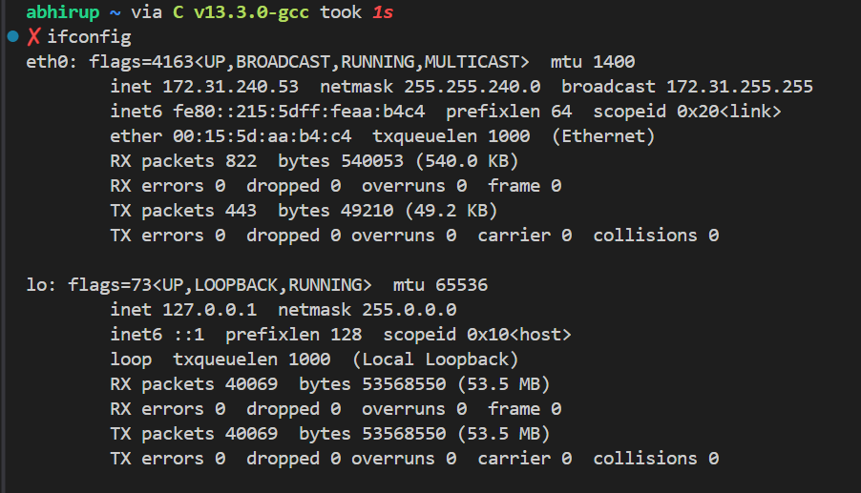

* 1. **ip (Linux)**

Displays and configures IP addresses.

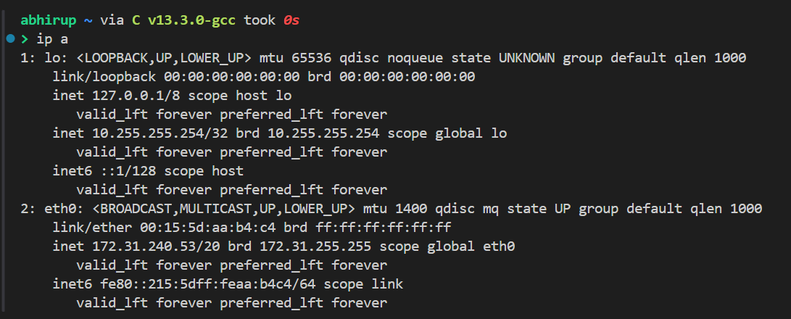

* 1. **hostname**

Displays or sets the system’s hostname.

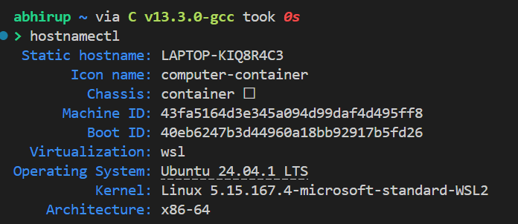

* 1. **ping**

**Tests network connectivity.**

Example:

ping 10.10.101.135

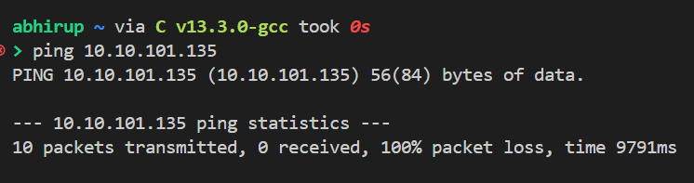

* 1. **netstat**

Displays network connections and statistics.

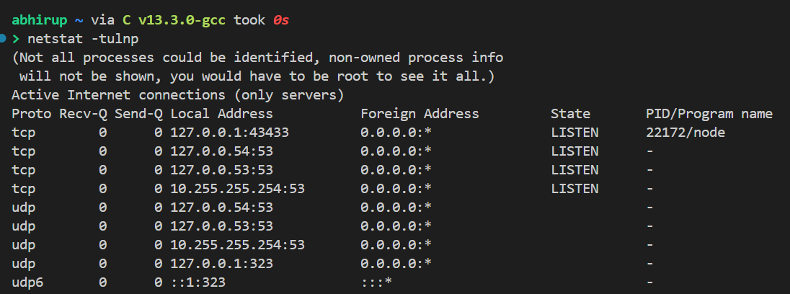

* 1. **route**

Displays/manages routing table.

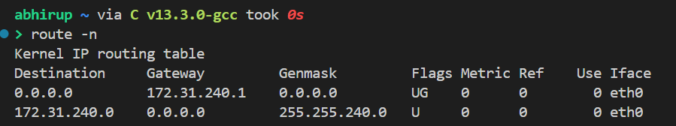

* 1. **traceroute (Linux) / tracert (Windows)**

Traces the route packets take to a destination.

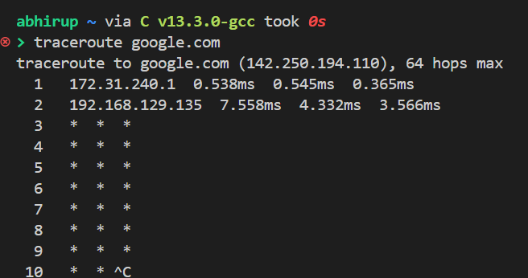

* 1. **tcpdump**

Captures and analyzes network traffic (Linux).

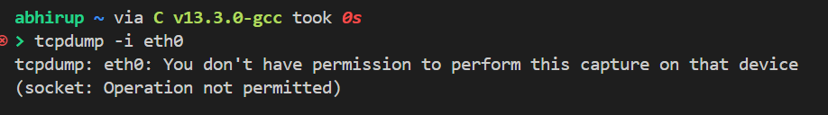

* 1. **Wireshark**

Graphical tool for analyzing network packets.

1. **Open Wireshark.**

A GUI-based network packet analyzer.

* Open Wireshark.
* Select the network interface.
* Start packet capture.
* Apply filters (e.g., tcp.port == 80).

1. **Conclusion**

This report covered the preparation of network cables, IP address configuration, and essential networking tools. Understanding these basics is crucial for network administration and troubleshooting.

1. **References**

* ANSI/TIA-568.2-D (TIA)
* IEEE 802.3 (IEEE)
* RFC 791 (IETF)
* RFC 2131 (IETF)
* RFC 792 (IETF)
* Microsoft Official Documentation ([Microsoft Docs](https://docs.microsoft.com/en-us/windows-server/networking/))
* Linux Man Pages
* Wireshark User Guide (Wireshark Docs)